|  |  |  |
| --- | --- | --- |
| UNIFORM ITEMS | PRICE | SIZE |
| **Short Sleeve Polo Shirt** Size 4-14 / S – 2XL | $26.00 |  |
| **Long Sleeve Polo Shirt** (Ragtagd included) Size 4-14/S-2XL | $30.00 |  |
| **School Windcheater** Size4-14 / S – 2XL | $35.00 |  |
| **Bomber Jacket** (Ragtagd included) Size 4-XL | $35.00 |  |
| **Unisex Shorts** Size 4-XL | $17.50 |  |
| **Unisex Track Pants** Size 4-L | $22.00 |  |
| **Leggings** Size 4-14 / S-XL | $17.00 |  |
| **Skorts** Size 4-XL | $18.00 |  |
| **Reader Folder** | $12.00 |  |
| **School Hats** Small or Large | $7.50 |  |



**Salisbury Downs Primary School Name:**

**Uniform Price List and Order Form Class:**



**Salisbury Downs Primary School Name:**

**Uniform Price List and Order Form Class:**

|  |  |  |
| --- | --- | --- |
| UNIFORM ITEMS | PRICE | SIZE |
| **Short Sleeve Polo Shirt** Size 4-14 / S – 2XL | $26.00 |  |
| **Long Sleeve Polo Shirt** Size 4-14 / S – 2XL | $30.00 |  |
| **School Windcheater** 4-14 / S – 2XL | $35.00 |  |
| **Bomber Jacket** (Ragtagd included) Size 4-XL | $35.00 |  |
| **Unisex Shorts** Size 4-XL | $17.50 |  |
| **Skorts** Size 4-XL | $18.00 |  |
| **Unisex Track Pants** Size 4-L | $22.00 |  |
| **Leggings** Size 4-14 / S-XL | $17.00 |  |
| **Reader Folder** | $12.00 |  |
| **School Hats** Small or Large | $7.50 |  |

**Salisbury Downs Primary School**

Salisbury Downs Primary School are now using a Smart Tag system to help recover lost items. Smart Tags for clothing garments and Stickers for items such as lunch boxes and drink bottles etc.

Smart Tags are available in **a Pack of 2 for $5.00** or a **Pack of 5 for $10.00**. Smart stickers are available in a **Pack of 5 for $7.00.**

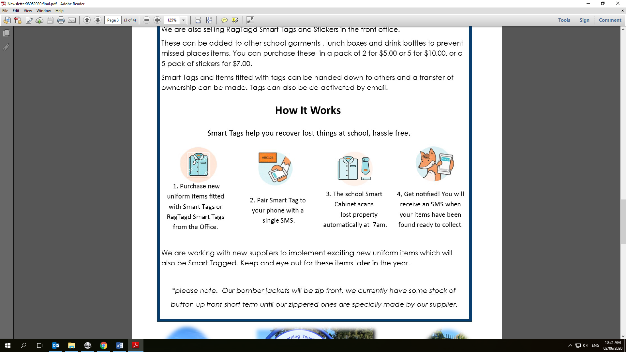

Salisbury Downs Primary School are now using a Smart Tag system to help recover lost items. Smart Tags for clothing garments and Stickers for items such as lunch boxes and drink bottles etc.

Smart Tags are available in **a Pack of 2 for $5.00** or a **Pack of 5 for $10.00**. Smart stickers are available in a **Pack of 5 for $7.00.**

